 Name:

|  |  |  |
| --- | --- | --- |
| **Calculator Free** | **/28** | **%** |
| **Calculator Assumed** | **/28** | **%** |
| **Total** | **/56** | **%** |

**Mathematics Methods, Year 12, 2018**

**Test 4 – Logarithmic functions and calculus involving logarithmic functions.**

30 minutes working time.

Calculator Free Section (no notes, no calculators)

SCSA Formula sheet allowed

**Question 1 [6 marks: 1, 2, 3]**

Solve each of the following equations for $x$.

$\log_{2}x=5$

$ln\left(3x+1\right)= 0$

$\ln\left(x-1\right)+\ln\left(x+2\right)=ln⁡(6x-8)$

**Question 2 [5 marks: 1, 2, 2]**

Express each of the following as the logarithm of a single term.



$log 9-log 3$

$\frac{1}{2}log36-\frac{1}{3}log27-\frac{2}{3}log8$

$2\log{5}+2\log{2}+1$

**Question 3 [4 marks]**

For the following function, sketch the graph, labelling axis intercepts and asymptotes $.$

$y=\log_{4}\left(x+4\right)+2$

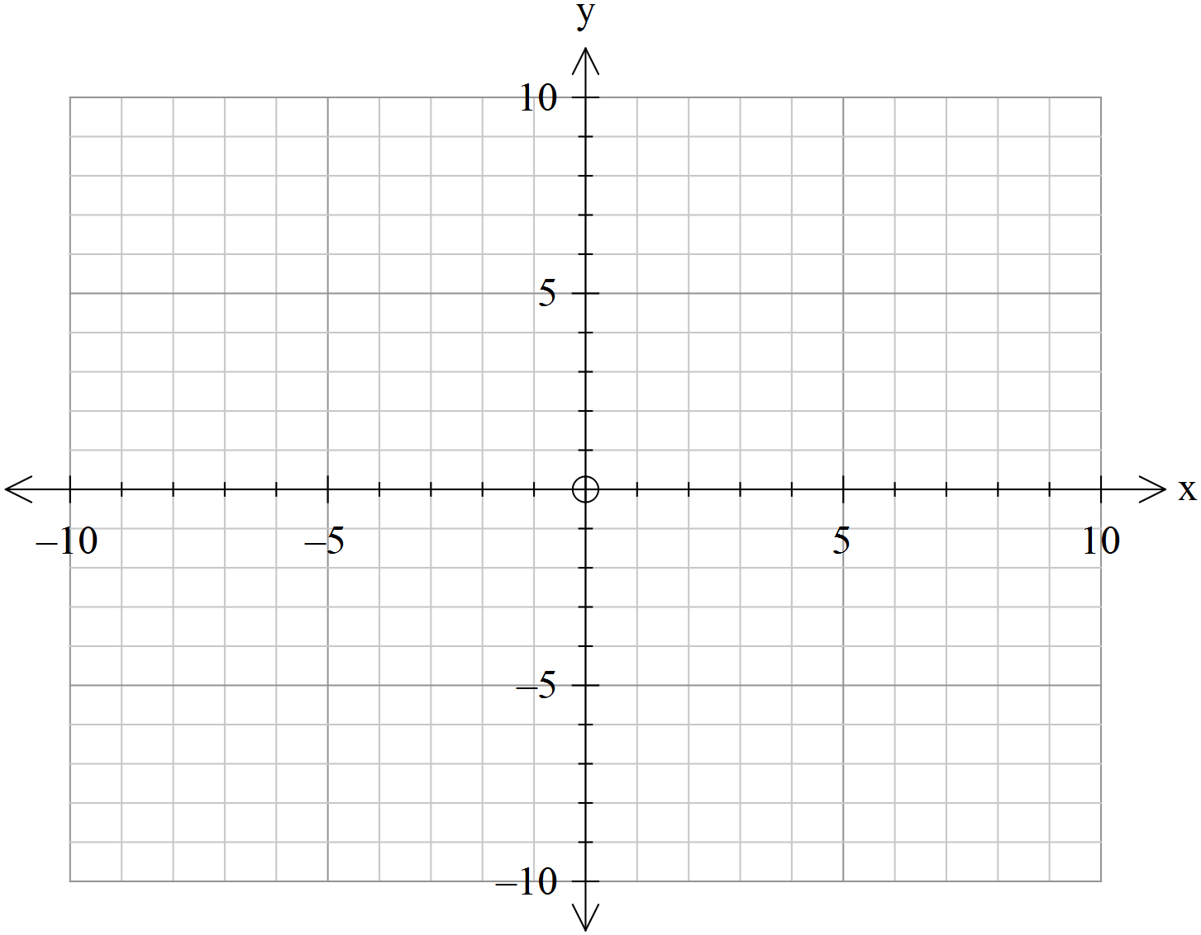

**Question 4 [7 marks: 1, 3, 3]**

Use common logarithms to solve for $t$.

$4^{t}=17$

$3^{t}= 5^{1+2t}$

$3^{2x}+3\left(3^{x}\right)-4=0$

**Question 5 [4 marks: 1, 3]**

Differentiate the following:

$y=\ln{x^{4} }$

$y=ln\frac{1+2x}{1+x^{2}}$

**Question 6 [2 marks]**

Find the following integral.

$$\int{\frac{-\cos{x}}{\sin{x}}} dx$$

Name:

|  |  |  |
| --- | --- | --- |
| **Total** | **/28** | **%** |

**Mathematics Methods, Year 12, 2018**

**Test 4 – Logarithmic functions, Calculus involving logarithmic functions.**

Calculator Assumed Section (notes allowed) 30 minutes working time.

SCSA Formula sheet and calculators allowed

**Question 7 [3 marks]**

The shaded region shown in the accompanying diagram is trapped by the lines $x=2 and x=4$ and curve with equation $y=\frac{2}{x-5}+1$. Find the exact area of the shaded region.

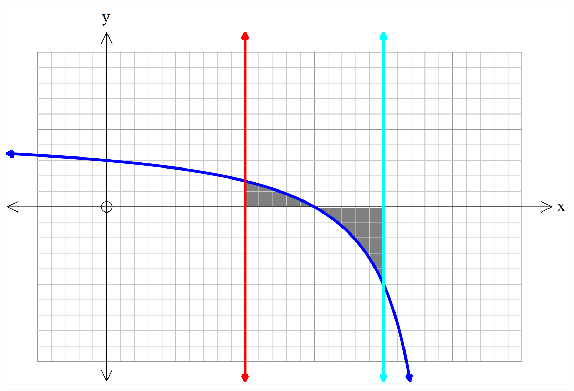

**Question 8 [4 marks]**

Given that $f\left(x\right)= 4x^{2}ln{ x}^{2}$. Use calculus techniques to find the exact coordinates of the stationary points on the curve $y=f(x)$

**Question 9 [5 marks]**

A particle moves in a straight line with acceleration $\left(a\right)$ given by

$a=\frac{8}{({t+3)}^{2}} m/s^{2}$

If the particle’s initial displacement, from rest, is zero, find, correct to one decimal place, the displacement at $t=10 seconds.$

**Question 10 [9 marks: 2, 2, 2, 3]**

Laura is starting a new fitness routine and she completes 2 sets of 5 repetitions of squats each day. Her aim is to get stronger and lift heavier each day.

Laura models her progress over t days by the function: $f\left(t\right)=5+k ln(t+10)$, where $f (t)$ is the weight in kilograms of her squat each day.

1. Calculate the value of k if initially Laura lifts 30 kg.
2. After 2 weeks of training, by how many kilograms has her strength increased?
3. Calculate the rate of change of Laura’s strength with respect to time.
4. Determine when Laura’s increase in strength is half of what it was initially.

**Question 11 [7 marks: 3, 2, 2]**

The instantaneous rate of change of the number of fish over t weeks, being farmed in a fish farm can be modeled by $P^{'}\left(t\right)= \frac{-4970}{t+e}$ where $P(t)$ is the population after $t$ weeks.

1. If after 5 weeks there are 12 000 fish left, determine an expression for $P(t).$
2. Calculate the initial number of fish when the study began.
3. When the decline in fish each week falls below 500, the farmer is no longer as concerned for his fish stock. During which week does this occur?